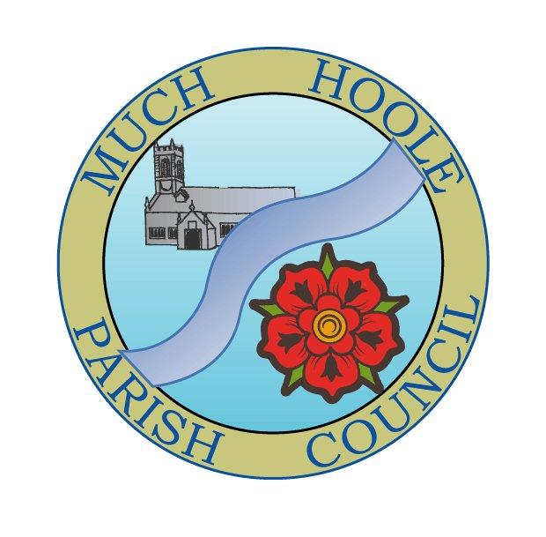 | MUCH HOOLE PARISH COUNCIL  NOTICE OF MEETING
You are hereby summoned to attend the Meeting of Much Hoole Parish Council to be held at 7.30pm on Monday 13th September 2021. The meeting will be held at the Venue (Hoole memorial village hall) Liverpool Road.
Russ Weaver, Clerk

AGENDA
1. | Apologies for Absence  To receive apologies for absence. Cllr Taylor is abroad
2. | Declaration of Interests and Dispensations  - To receive declarations of interest from Councillors on items on the agenda  - To receive written requests for dispensations for disclosable pecuniary interests (if any)  - To grant any requests for dispensation as appropriate
3. | Minutes of the Previous Meetings  To resolve to approve as a correct record the Minutes of the Council Meeting held on the 12th July 2021
4. | Public Time  To invite and listen to issues raised by members of the public.
5. | Off Road Cycle Track  To consider any updates on the Cycle track and resolve any actions required.
6. | Finance and Audit  To resolve to authorise payment of the following:  - To resolve to pay the clerk salary in the sum of £480 (net) for July and August  - To resolve to pay the Clerk expenses for mileage for July/Aug in sum of £9.00  - To resolve to pay HMRC in sum of £120 PAYE for July and August  - To resolve to pay invoices for Lengthsman as follows: TOTAL £858.57  Invoices (90) £103.70, (94) £251.45, (95) £142.41,(105) £257.18 and (109) £103.83  - To NOTE the budget v spend summary as at 1st September (Halfway point of financial year)  - To NOTE the progress of the external audit
7. | Community led projects  To discuss and update progress on the spending of community funding.  To note that LCC is inviting applications for the Parish Council Champions Fund to support local projects. Councillors are asked to consider whether there are any suitable projects that would benefit from the fund.  To consider a proposal to plant a Jubilee Tree to mark the Queen’s Platinum Jubilee
8. | Draft Newsletter  To consider the draft newsletter and resolve to publish a newsletter prior to the next meeting at an approximate cost of £300
9. | Planning  There have been no planning applications relating to Much Hoole
10. | Local Meetings (for information only)  To receive any reports from local meetings.
11. | Items for the Next Agenda (for information only)  To highlight issues for the next agenda
12. | Date of Next Meeting  The Parish Council to agree the date of the next meeting as 7.30pm Monday 11th October 2021, to be held at the Venue, Liverpool Road, Much Hoole.

